Output of the ProductDispensor.csproj file:

Note: Project has been created using Visual Studio Code only(Framework 5.0)
To run the main project file:
- Set the path to ProductDispensor.csproj folder path
- Pass the command “dotnet run” and press enter key in Terminal in Visual Studio Code as shown below.

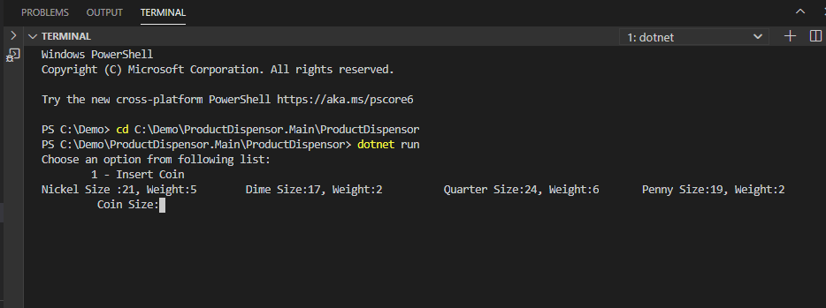
- Fill Coin Size and Weight, e.g. sample size has been given above
- Once value filled then it will display below screen
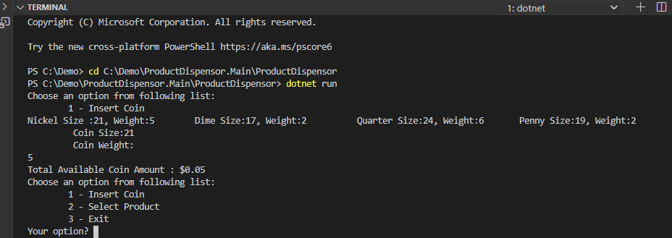
- Here customer have an option to insert the coin or select the Product
- Lets say, he want to select Product and fill the option as 2 and press enter key, then it will display below screen
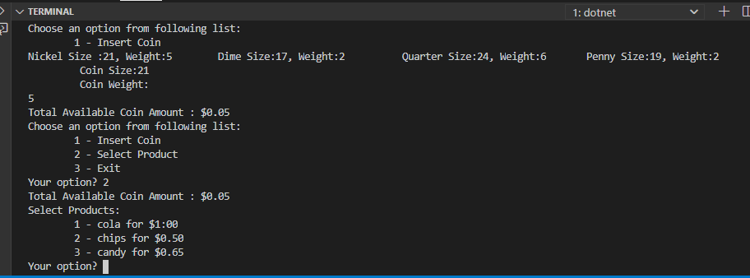
- Select the appropriate product from option 1, 2 and 3.
- Lets select option value 2 for chips, it will display below screen
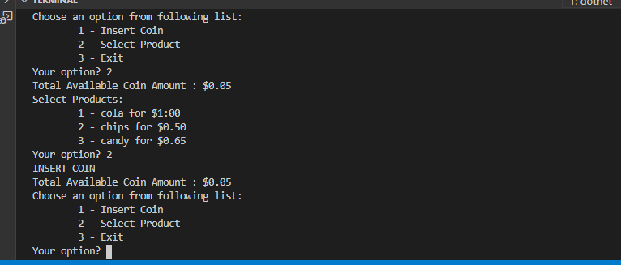
- It will prompt customer to insert the coin as balance is sufficient to get the product
- To get the product, customer needs to insert more coins, lets insert coin quarter
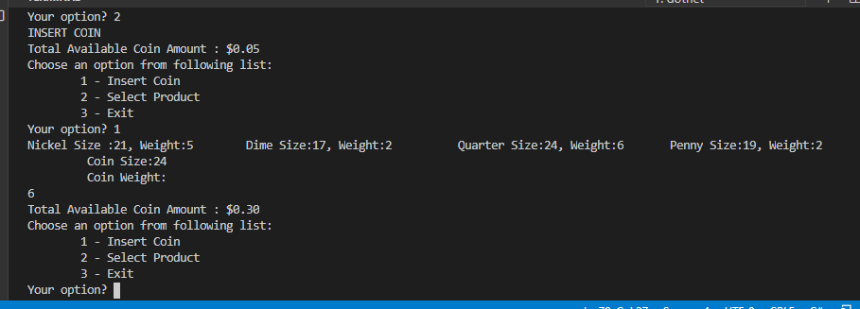
- Once we insert coin quarter, total available coin amount is getting increased. But still that value is less to select the product, so we will add quarter One more time
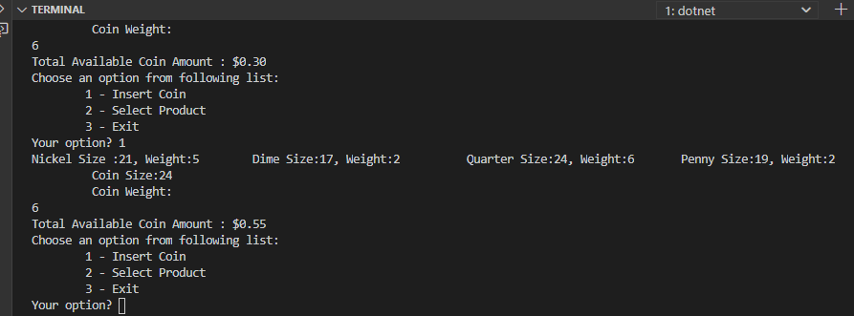
- Again Total available coin amount has been increased.
- Now select the option to 2 for product, it will display below screen with products and price
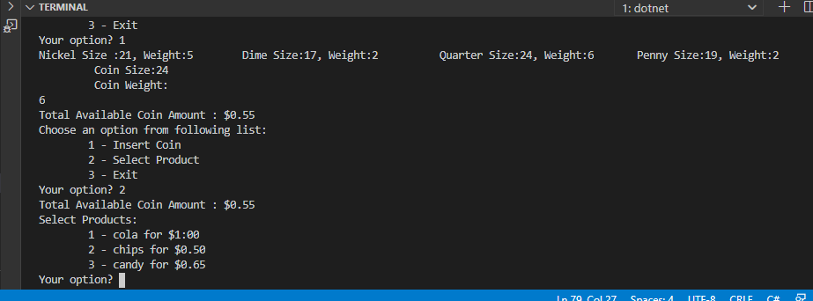
- Select Option 2 to get chips
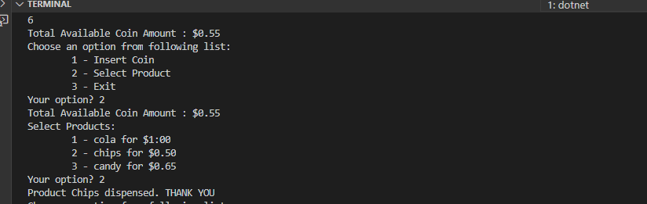

To verify the unit testing from the Visual Studio Code :
- Set the ProductDispensor.Test.csproj folder path
- Pass the command “ dotnet test ProductDispensor.Test.csproj” and press enter key in terminal in Visual Studio Code
